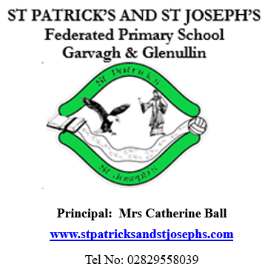
September / October 2025

Dear Parent/Guardian

Welcome / Fáilte to all our pupils, back for the
new academic year.

A special welcome to all of our Primary One pupils

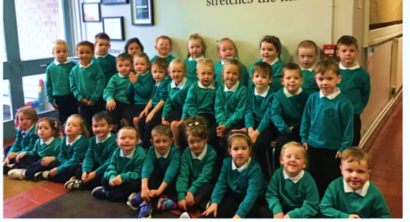
Back Row (Left to Right): Faolan McIlvar, Flo Mullan, Ceallachan O’Kane, Róise O’Kane, Grace Conway, Anna O’Kane, Noel Mullan, Michael Higgins

Middle Row (Left to Right): Fionn O’Kane, Joseph Fisher, Hugh Niblock, Paige O’Kane, Peadar Mac Niocall, Eanna McNicholl, Colton Hanna-Williams, Aoibheann O’Kane, Danny McNicholl, Martin McIlvar, Sé Bradley

Front Row (Left to Right): Nora McGilligan, Alannah O’Kane, Alice Holmes, Seamus McCloskey, John Mullan, Pauric McCloskey, Amelia McMullan, Theodora McCloskey, Aubrey Mullan, Oisin McNicholl
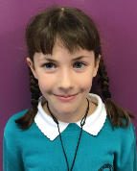

We wish to welcome two other new pupils, Patrick Mullan in P2 and Cara McIlvar in P5.

We are absolutely delighted with how well our new children have settled into school life. Their confidence, enthusiasm, and growing independence have been a joy to witness.
As part of helping them become familiar with their daily routine, we kindly ask that from Monday morning, parents on the Tirkeeran site drop off their child at the gate. A member of staff will be there to warmly welcome them and guide them safely to their classroom.
This small step encourages independence and helps the children feel confident as they get to know their new environment.
Thank you for your continued support as we work together to give your child the best possible start to their school journey.
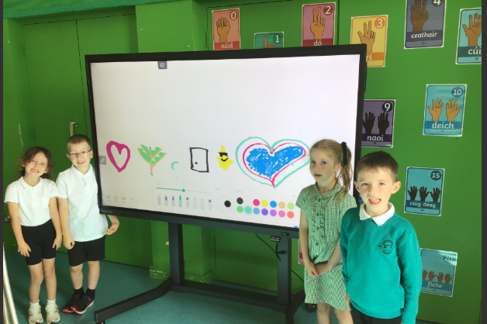
New Clevertouch Interactive White Board
A Heartfelt Thank You
I would like to extend my sincere thanks to the Parent’s Association, all parents, and the wider community who supported and attended the Fun Run in June 2025. Your generosity and enthusiasm made the event a tremendous success.
Thanks to the funds raised – along with a generous anonymous donation – we were able to purchase another much needed Clevertouch board for the Tirkeeran site. This new resource has already proven to be a valuable asset, especially during our wet weather days, and we look forward to the many ways it will enhance teaching and learning in the years ahead.

Canonisation of Blessed Carlos Acutis Sunday 7th September 2025
Blessed Carlos Acutis, the first millennial to be canonised, was known “as the kid in jeans and sneakers”. He died of leukaemia at just 15 years of age in 2006. Carlo had a passion for holiness, focusing his life on the Eucharist in order to grow in his relationship with Jesus.
To celebrate the canonisation, St Eugene’s Cathedral will be holding a veneration of first-class relics with a rosary and music, this Sunday, September 7, from 3pm-6.30pm. Bishop Donal McKeown will be holding a Mass of Thanksgiving at 7pm.
Collection of Children from EA Bus  It is important to note that, according to the EA Transport policy, our school bus driver cannot let children off the bus unless a responsible adult is there to collect them.  Start of Year Mass  Father Crowley will celebrate Mass with the staff and children of the school, date to be confirmed. It will be a great occasion where the whole school community can come together and pray for a successful and happy year. Parents are very welcome to attend and join the celebration.  P6 Assembly  P6 will perform their assembly for their parents on Friday 10 October. This is a great opportunity for our wonderful P6 children to showcase their talents.  Attendance  Pupils who have any sickness should remain at home until well enough to return to school. |  |  | Dates for Term One  Wednesdays 3 Sept – 1 Oct Swimming starts for the P7 class. Pool closes for renovations from 6 Oct until Jan 26  Wednesdays Once a month Adoration for P4-7  Thursday 4 Sept Library visits starting with P 7  Wednesday TBC School Mass  Friday 3 Oct M& M Productions will perform Robin Hood for the whole school  Monday 6 Oct Lafayette school photography  Friday 10 Oct P6 Assembly  Week beginning 20 Oct Parent / teacher meetings – After school, dates and times to follow  Monday - Friday 27 – 31 Oct – incl. Hallowe’en holidays  Wednesday 12 Nov P2 Assembly  Friday 19 Dec School closes at 12 noon  Monday 5 Jan School reopens.
Library Visits  Each class will have the opportunity to visit Garvagh library between now and Christmas. This is a great support and enhances the excellent provision for reading in the school.  Parents’ Association  The annual AGM will be held in October, date to be confirmed, at 8pm in the Tirkeeran site. The more parents who participate, the stronger our team will be.  Parent Meetings  Parent meetings will be held week beginning Monday 20 October. Meetings will take place after school in the hall at the top site. Parents will be given a time and meeting will last 10 minutes.    Hallowe’en Dress –up  On Friday 24 October the children are invited to dress up for Hallowe’en. The children are sure to have a spooktacular day full of fantastically fun, ghoulishly gruesome activities. All children will be entered into a draw to win a Hallowe’en hamper on each site.  £1 donation requested for Mary’s Meals. |  |  | Child Protection and Safeguarding.  Children are encouraged to share any worries with their parents, and in school with any adult. The school will remind children regularly that Mrs McCloy and Miss Conway (Designated Teachers for Child Protection), Mrs Ball and Mrs Heron (Deputy Designated Teachers) are always available to handle any concerns.      During/Afterschool Clubs  Tuesdays 2-3pm 16 Sept – 14 Oct Stay & Play for P1 & P2 Children should be picked up from the Tirkeeran site at 3pm unless travelling to Appletree’s in the school bus  Wednesdays 10 Sept – 15 Oct Handball with Mrs Ball for P5 from 2-3pm  Wednesdays Starting 10 Sept Choir for P4-7 with Mrs Bradley from 3-4pm  Thursdays 11Sept – 17 Oct Football for P6/7 boys with Mr Dillon from 3-4pm  Fridays 12 Sept Traditional Group with Mrs Bradley from 2.15-3pm
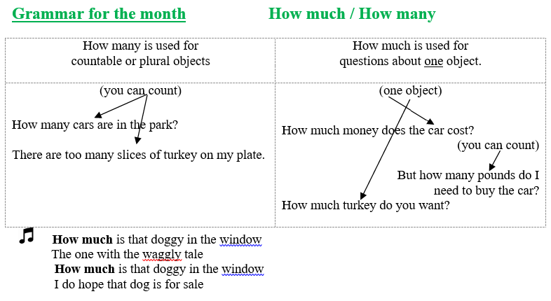
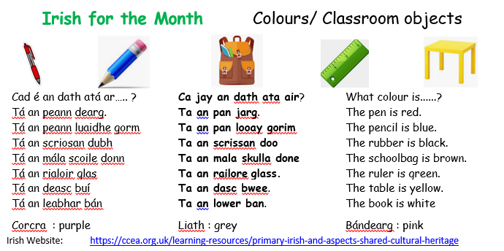
  TOPICS  The children enjoy learning all about the world around them. In learning through their topics children are able to apply their learning and develop cross-curricular skills. |  |   We understand that on occasions it is virtually impossible and impracticable for your child to complete their homework. When this is the case simply send the teacher a Dojo explaining that your child was unable to complete their homework.  No further explanation is necessary. It is optional if you, the parent, wants the child to complete the homework on a different night.  Use of Children’s images  The school has a number of parents who have not given permission for their child’s image to be used or reproduced by members of the public.
Primary 1 – There’s No-one Quite like Me
Primary 2 – Waoh Wee, Look at Me!
Primary 3 – Castles & Knights
Primary 4 – Autumn / Farm
Primary 5 – Where We Live
Primary 6 – Famine
Primary 7 - Rainforest
  School Dinners and Free School Meals  School dinners are available at a cost of £2.60 per day. To ensure smooth processing of payments:  - Please send money in a sealed envelope clearly marked with your child’s name,  - Cheques should be made payable to the Education Authority.  The number of pupils registered for Free School Meals directly affect our school’s budget and the resources we can provide. If you think you may be entitled, even if your child does not take a school dinner every day, we encourage you to apply. Forms are available on the Education Authority’s website, https://www.eani.org.uk/financial-help/free-school-meals-uniform-grants.  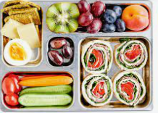  Boomerang Lunches  To encourage recycling and in order that parents can gauge what children have eaten for their lunch and break, the school has a boomerang lunch policy. This means that all packaging or uneaten lunch will return home in the pupils’ lunchboxes.  Allergies / Medical Needs  As you are aware a number of children within the school have severe allergies to nuts and/or eggs. An anaphylactic reaction to these foods can be life-threatening. To help us maintain a safe environment for all children, we kindly ask that you:  Check all food labels carefully before sending items to school to ensure they do not contain nuts or egg products.  Avoid sending birthday cakes or baked goods into school. Due to the risk of allergic reactions and the time required for staff to manage these safely, we are unable to accommodate these items.We appreciate your continued support in keeping our school safe and inclusive for all children.  Administering Medication  If your child has a medical condition and requires medication, please ensure the medication is in date. |  | Mathletics  Mathletics is an excellent fun maths learning programme. Pupils thrive on the competitive element of obtaining points by competing against other pupils online or by completing tasks independently. Pupils are given appropriately levelled activities which are in line with the Northern Ireland Curriculum. ‘Mathletics’ will be used both in school and at home.  The cost per pupil is £5 (approximately 10p for 52 weeks / 25p if only used for 20 weeks) with a maximum payable of £15 per family. Parents who subscribe will ensure their child has access to unlimited tutorials for 52 weeks.  We would urge all parents, regardless of the age or ability of your child to support this initiative as we believe that it is a relatively inexpensive way of significantly improving your child’s mathematical results.  The School Uniform  The school uniform helps our children to bond and encourages a sense of belonging to St. Patrick’s and St. Joseph’s P.S.  Our uniform consists of;  - a green sweatshirt with the school logo,  - a white polo shirt  - and either a black skirt or black trousers.  Leggings are not part of the school uniform. The girls may wear a green and white checked dress and if they wish, wear a neat pair of shorts under their skirt during physical activities.  It is extremely important that every item of your child’s uniform and any coats, are clearly labelled with their name using a permanent marker.  We ask all children to wear trainer footwear to help us ensure the health and safety of all pupils. For younger children trainers with Velcro are strongly recommended. If your child’s trainers have laces, please double knot them before they come to school. It is also recommended that long hair is tied back especially during P.E.  Please do not send toys or cards into school as these can get mislaid causing distress to the child.

