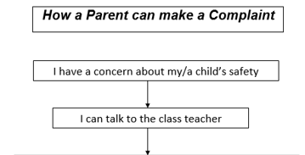
If I am still concerned, I can talk to the designated teachers Mrs McCloy or Miss Conway or deputy designated teachers Mrs Laura Heron or Mrs Ball (the school principal)

If I am still concerned, I can talk to the designated teachers Mrs McCloy or Miss

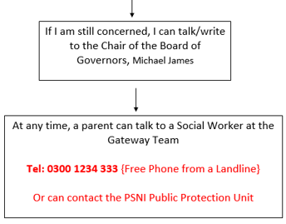

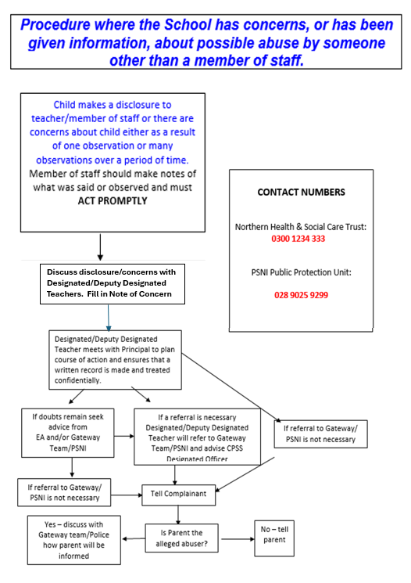

This leaflet is intended only as a summary of the main aspects of St Patrick’s & St Joseph’s Safeguarding Policy. The full policy is available on the website:
www.stpatricksandstjosephs.com

Safeguarding Policy
and Procedures
A Summary
St Patrick’s & St Joseph’s PS

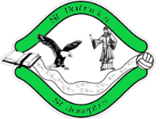
Our School Safeguarding Children Policy
Aims to protect and support each child’s development in ways which will foster a safeguarding ethos, security, confidence,
independence, and will be implemented by all personnel in the school.

Designated Teachers:
Mrs Claire McCloy
Miss Charlene Conway
Deputy Designated Teachers:
Mrs Laura Heron
Mrs Catherine Ball

Introduction

Safeguarding children is concerned with the provision of a suitable environment for children to develop and mature, safe, as far as possible, from psychological or physical harm.
All members of staff have a duty to help protect children from abuse or the risk of abuse and must be aware of correct procedures to safeguard all those in our care.
Staff see children on a day-to-day basis over long periods of time and are in a unique position to be able to notice physical and behavioural indicators which may be evidence of abuse. We aim to work closely with parents/guardians in supporting safeguarding. Any concerns will be raised in a professional manner.

Guiding Principles
The welfare of the child is paramount at all times.
Every child has a right to be heard, listened to and taken seriously.
The right to confidentiality for parents, carers, members of staff and pupils will be respected in so far as legal requirements permit.
Employees and all working with pupils are subject to Enhanced Disclosure Checks by Access N.I.

Designated Teacher
Any member of staff who knows or suspects that a child is being harmed or at risk of being harmed has a duty to convey his/her concern to the Designated Teachers- Mrs Claire McCloy or Miss Charlene Conway or the Deputy Designated Teachers- Mrs Catherine Ball or Mrs Laura Heron.
A Safeguarding Team consisting of members of the Board of Governors, the principal and members of the SLT is also in place, ensuring that safeguarding procedures are adhered to.

Responsibility to Report
Any member of staff who knows or suspects that a pupil is being harmed or is at risk of being harmed, has a duty to convey their concern to the Designated Teachers or Deputy Designated Teachers.

Every possible care is taken to minimise the possibility of mistaken referrals, but this cannot be guaranteed. The consequences of not reporting suspicions if a child has been abused could be far more serious than making a report which proves to be unfounded.

Signs and Symptoms of Abuse
Detection of abuse is seldom straightforward. None of the indicators either singly or in any combination, prove conclusively that a child has been abused.
Physical Abuse
- Unexplained bruises
- Human bite marks
- Unexplained marks / injuries
- Untreated injuries
- Self-destructive tendencies
- Chronic runaway
- Fear of going home
Emotional Abuse
- Bullying of others
- Difficulty in forming/ maintaining relationships with others
- Signs of mutilation
- Attention seeking
- Wetting and soiling
- Sudden speech disorders
- Low self-esteem
Neglect
- Poor hygiene
- Constant hunger
- Inappropriate clothing
- Constant tiredness
- Exposed to danger
- Untreated illness
- Compulsive stealing / begging
Sexual abuse
- Bruised or sore genitals
- Genital infection
- Difficulty in walking or sitting
- Inappropriate sexualised language or behaviour
- Low self-esteem
- Personality changes
- Fear of going home
Child Sexual Exploitation
- Child sexual exploitation is a form of sexual abuse where children are sexually exploited for money, power or status. It can involve violent, humiliating and degrading sexual assaults. Child sexual exploitation doesn’t always involve physical contact and can happen online.

Role of Staff Members

In the event that a staff member becomes aware or suspects that a child is a victim of child abuse it is important that the response is sensitive and appropriate.

In all cases, staff will act promptly, bringing concerns to the attention of the Designated Teachers, Mrs McCloy or Miss Conway or the Deputy Designated Teachers, Mrs Laura Heron or Mrs Ball (the school principal).

In cases where a child makes a disclosure, staff will:
- Listen to what the child says without showing or expressing shock.
- Allow the pupil to tell what has happened in his/her own words without interrupting or interrogating.
- Reassure the child that what they have said has been understood and that their interests are paramount
- Explain the obligation to refer the matter in order to seek help for the child.
- Not give a guarantee of confidentiality
- Make written notes at the earliest opportunity but not as the pupil talks. Staff will try to write down the actual words used.
- Keep notes factual and securely stored.
- Refer the matter to a Designated Teacher as a matter of urgency.

Who needs to know?

It is not always possible to provide teachers with the full details of a child's circumstances. Information is shared in the interest of the pupil's welfare, but this is balanced against pupil and parental rights to confidentiality.

Parents will be kept informed of who is notified within school and other agencies, unless doing so would place the child at further risk.

