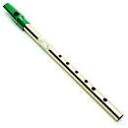St Patrick’s and St Joseph’s
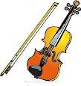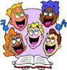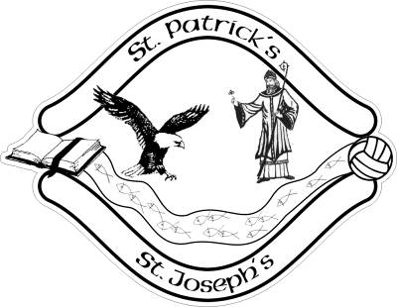
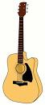

Music Policy

Music Policy

1 Aims and objectives

1.1 Music is a unique way of communicating that can inspire and motivate children. It is a vehicle for personal expression and it can play an important part in the personal development of people. Music reflects the culture and society we live in, and so the teaching and learning of music enables children to better understand the world they live in. Besides being a creative and enjoyable activity, music can also be a highly academic and demanding subject. It also plays an important part in helping children feel part of a community. We provide opportunities for all children to create, play, perform and enjoy music, to develop the skills to appreciate a wide variety of musical forms, and to begin to make judgements about the quality of music.

1.2 The aims of music teaching are to enable children to:
- know and understand how sounds are made and then organised into musical structures;
- know how music is made through a variety of instruments;
- know how music is composed and written down;
- know how music is influenced by the time, place and purpose for which it was written;
- develop the interrelated skills of performing, composing and appreciating music.

2 Teaching and learning style

2.1 At St Patrick’s and St Joseph’s Primary School we make music an enjoyable learning experience. We encourage children to participate in a variety of musical experiences through which we aim to build up the confidence of all children. Singing lies at the heart of good music teaching. Our teaching focuses on developing the children’s ability to sing in tune and with other people. Through singing songs, children learn about the structure and organisation of music. We teach them to listen and to appreciate different forms of music. As children get older, we expect them to maintain their concentration for longer and to listen to more extended pieces of music. Children develop descriptive skills in music lessons when learning about how music can represent feelings and emotions. We teach them the disciplined skills of recognising pulse and pitch. We also teach children how to work with others to make music, how individuals combine together to make sounds and how to compose music to play together.
We provide the opportunity for all pupils to learn to play the tin whistle from Primary three on and incorporate with this the teaching of musical notation.

2.2 We recognise that there are children of widely different musical abilities in all classes, so we provide suitable learning opportunities for all children by matching the challenge of the task to the ability of the child. We achieve this in a variety of ways by:
- setting common tasks which are open-ended and can have a variety of responses;
- setting tasks of increasing difficulty (not all children complete all tasks);
- grouping children by ability in the room and setting different tasks to each ability group;
- providing resources of different complexity depending on the ability of the child;
- using classroom assistants to support the work of individuals or groups of children

3 Additional music teaching

3.1 Children are offered the opportunity to study a musical instrument with a teacher. Children can chose to learn the guitar, classical flute, violin and tin whistle.

4 Music curriculum planning

4.1 Our school uses the music express programme for its curriculum planning. We have adapted the Programme of Study so that the topics that the children study in music build upon prior learning.

Our music planning is geared to three aspects of progress:
- increasing breadth and range of musical experiences;
- increasing challenge and difficulty in musical activities;
- increasing confidence, sensitivity and creativity in the children’s music making.

5 The contribution of music to teaching in other curriculum areas

5.1 English
Music contributes significantly to the teaching of English in our school by actively promoting the skills of reading, writing, speaking and listening. Children develop their language skills through singing songs, with attention to diction, meaning, rhythm and rhyme. They use reference books and develop research skills when finding out about the history of music and musicians. Music is also used to stimulate discussion or creative writing. Through working with others in a musical setting, children develop their ability to communicate ideas effectively.

5.2 Mathematics
Music contributes to the teaching of mathematics in that children who study the structure of music are observing patterns and processes. Talent in music is often linked with talent in mathematics, as the rhythm and structure of music is mathematically based.

5.3 Information and communication technology (ICT)
ICT is used in music where appropriate. Children use computer programmes to compose music. They also use ICT in music to enhance their research skills through the Internet and CD ROMs. Children improve the presentation of their work through the use of ICT.

5.4 Spiritual, moral, social and cultural development
Listening, creating or performing music can sometimes be a moving and even spiritual experience. We encourage children to reflect on the important effect that music has on people’s moods, senses and quality of life.

6 Teaching music to children with special needs

6.1 We teach music to all children, whatever their ability.

7 Assessment and recording

  - Teachers assess children’s work in music by making informal judgements as they observe them during lessons.

8 Resources

8.1 There are sufficient resources for all music teaching in the school. We keep some resources for music in a central store and there is a set of percussion instruments for each site.

9 The school choir/orchestra and musical events

We believe that music enriches the lives of people, and so we wish to involve as many children as possible in musical activities. We have a school choir which we encourage children from P3 to P7 to join. The choir meets on a weekly basis and, although its primary aim is to enable children to enjoy singing together, it also performs in public on a number of occasions throughout the year.

    - When we have a sufficient number of children learning a musical instrument, we provide opportunities when they can learn to enjoy playing music in an ensemble.

9.2 Through the common goal of making music, children learn to work effectively with other people and build up good relationships. Music is the basis of many social activities and has an important role to play in the personal development of many young people. It has a vital role to play in building self-confidence. We provide times during the year when the whole school comes together to sing and share their musical talents, e.g. Christmas Carol Concerts and St Patrick’s Day Celebrations

10 Monitoring and review

10.1 The music Coordinator is responsible for the standard of children’s work and for the quality of teaching in music. The work of the Coordinator also involves supporting colleagues in the teaching of music, being informed about current developments in the subject and providing a strategic lead and direction for the subject in the school. The music Coordinator is responsible for giving the principal an annual summary report in which she evaluates the strengths and weaknesses in the subject and indicates areas for further improvement.

Signed:

Date:

