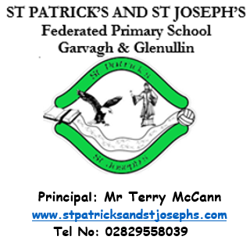
September 2023

Dear Parent/Guardian

Welcome / Fáilte to all our pupils, back for the
new academic year.

A special welcome to all of our Primary One pupils:

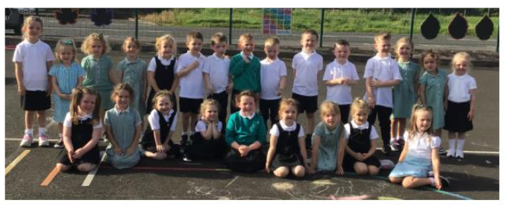
Back Row (L to R): Meabh McLaughlin, Kaia McNicholl, Connie McNicholl, Ava Bradley, Emily Holmes, Finn Mullan,
Iarlaith McIlvar, Jarlath O’Kane, Francis McLaughlin, Pauric McLaughlin, Daithi O’Kane, Oisin Jamison, Sive Young,
Róise McCloskey, Therese O’Kane
Front Row (L to R): Eva-Grace Mullan, Aoife-Rose McNicholl, Eimear McCloskey, Isabella McCloskey, Ria Bradley, Aoibheann NicNiocaill, Saoirse Moran, Grace McNicholl and Aoife O’Kane
Mr T McCann  I would like to extend a very warm welcome to the new Primary One pupils and to all our pupils back for the new academic year.  Thank you to all parents for making our morning drop off such a success. Please note;  - Both sites are open from 8.30am – children should not be dropped off before 8.30am  - Please reverse cars into car parking bays at both sites  - Inter-site transport is available from Tirkeeran to Glenullin at 8.30am and from Glenullin Chapel car park to Tirkeeran at 8.45am  Collection of Children from EA Bus  It is important to note that, according to the EA Transport policy, our school bus driver cannot let children off the bus unless a responsible adult is there to collect them.  Attendance  Pupils who have any sickness should remain at home until well enough to return to school. |  |  | Dates for Term One  Thursdays 7 September Swimming starts for the P7 class  Wednesdays Once a month Adoration for P4-7  Thursday 7 September Library visits starting with Primary 7  Wednesday TBC School Mass  Friday 29 September P6 Assembly  Week beginning 23 October Parent / teacher meetings – After school, dates and times to follow  Thursday 26 October P5 Assembly  Monday - Friday 30 October – 3 November incl. Hallowe’en holidays  Friday 24 November P4 Assembly  Thursday 21 December School closes at 12 noon  Thursday 4 January School reopens.
Start of Year Mass  Father Crowley will celebrate Mass with the staff and children of the school on Wednesday, date to be confirmed, at 10am in the GAA hall. It will be a great occasion where the whole school community can come together and pray for a successful and happy year. Parents are very welcome to attend and join the celebration.  This month the children will be singing a number of hymns as they prepare for the Start of Year Mass.  Sing Hosanna  We Come to You Lord Jesus  Ephesian Prayer  Go Now in Peace  Song of the Month:  We Come To You Lord Jesus  We come to you Lord Jesus  To say our thanks to you  And in our hearts we give ourselves  And everything we do.  Chorus:  We love you Lord Jesus  Stay with us we pray  Help us to be more like you each day.  We bring the bread, we bring the wine,  We offer them to you,  We bring our work, we bring our play,  And everything we do.  Chorus  Your love for us, our love for you,  We celebrate today,  Oh, fill our hearts with peace and joy,  Be with us, Lord, we pray.  Chorus  Parents’ Association  The annual AGM will be held on Monday 25 September at 8pm in the Tirkeeran site. The more parents who participate, the stronger our team will be. |  |  | P6 Assembly  P6 will perform their assembly for their parents on Friday 29 September. This is a great opportunity for our wonderful P6 children to showcase their talents. We would ask that parents use the hand sanitisers on the way in.  Child Protection and Safeguarding.  Children are encouraged to share any worries with their parents, and in school with any adult. The school will remind children regularly that Mrs Ball (Designated Teacher for Child Protection), Mrs McCloy and Mrs Heron (Deputy Designated Teachers) are always available to handle any concerns.  Library Visits  Each class will have the opportunity to visit Garvagh library between now and Christmas. This is a great support and enhances the excellent provision for reading in the school.  Parent Meetings  Parent meetings will be held week beginning Monday 23 October. Meetings will take place after school in the hall at the top site. Parents will be given a time and meeting will last 10 minutes.  Hallowe’en Dress –up  On Friday 27 October the children are invited to dress up for Hallowe’en. The children are sure to have a spooktacular day full of fantastically fun, ghoulishly gruesome activities. All children will be entered into a draw to win a Hallowe’en hamper on each site.  During/Afterschool Clubs  Mondays 5 Sept – 4 Nov Choir P5 – P7  Thursdays Starting 14 Sept Gaelic with Andrena  Thursdays 2-2.45pm 21 Sept – 26 Oct Foundation Fun Club for P1 & P2 Children should be picked up from the Tirkeeran site at 3pm unless travelling to Appletree’s in the school bus  Thursdays 21 Sept – 26 Oct Gaelic with Mr McCann for P4 & P5 boys  Thursdays 9 Nov – 14 Dec Camogie with Mr McCann for P4 & P5 girls
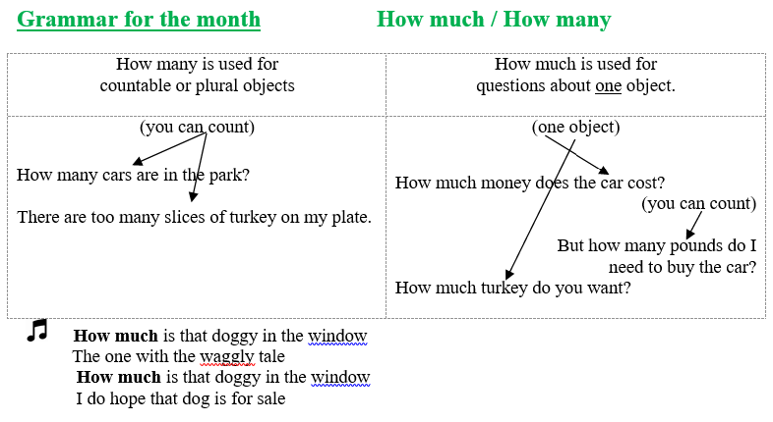
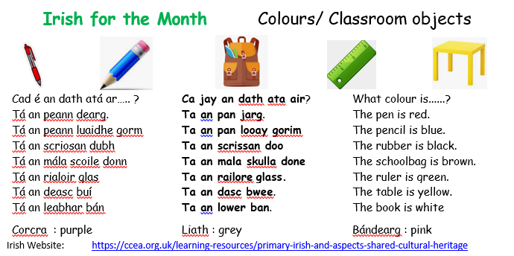
TOPICS  The children enjoy learning all about the world around them. In learning through their topics children are able to apply their learning and develop cross-curricular skills. |  | We understand that on occasion it is virtually impossible and impracticable for your child to complete their homework. When this is the case simply send the teacher a dojo explaining that your child was unable to complete their homework.  No further explanation is necessary. It is optional if you the parent wants the child to complete the homework on a different night.
Primary 1 – All About Me
Primary 2 – Wow Wee, Look at Me!
Primary 3 – Castles & Knights
Primary 4 – Mighty Me
Primary 5 – Where We Live
Primary 6 – Famine
Prmary 7 - Rainforest
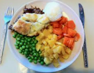  School Dinners and Free School Meals  School dinners cost £2.60 per day, please send in an envelope. Please make cheques payable to the Education Authority.  The number of pupils who are on the free school meals’ register affects the school budget. If you are in any doubt as to whether you are entitled to free dinners please complete a Free School Meals’ form which is available via the Education Authority’s website, https://www.eani.org.uk/financial-help/free-school-meals-uniform-grants, even if you do not wish your child to actually take dinner.  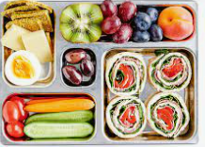  Boomerang Lunches  To encourage recycling and in order that parents can gauge what children have eaten for their lunch and break the school has a boomerang lunch policy. This means that all packaging or uneaten lunch will return home in the pupils’ lunchboxes  Use of Children’s images – a reminder  The school has a number of parents who have not given permission for their child’s image to be used or reproduced by members of the public.  Notice Boards  Notice Boards are provided on each site to:  - Highlight pupils or past pupils’ achievements outside of school.  - Include local notices and important dates for the children, for example Gaelic, camogie or music information.  Anyone who wishes to include any information, please submit to Mrs Bradley, the school secretary. |  | Mathletics  Mathletics is an excellent fun maths learning programme. Pupils thrive on the competitive element of obtaining points by competing against other pupils online or by completing tasks independently. Pupils are given appropriately levelled activities which are in line with the Northern Ireland Curriculum. ‘Mathletics’ will be used both in school and at home.  The cost per pupil is £5 (approximately 10p for 52 weeks / 25p if only used for 20 weeks) with a maximum payable of £15 per family. Parents who subscribe will ensure their child has access to unlimited tutorials for 52 weeks.  We would urge all parents, regardless of the age or ability of your child to support this initiative as we believe that it is a relatively inexpensive way of significantly improving your child’s mathematical results.  We encourage all children to reach 1,000 points per week.  Gold Certificates (Requires 4 Silver) Silver Certificates (Requires 5 Bronze) Bronze Certificates (1,000 points in a one week period)  When a child receives a Gold certificate, at end of the month, they go to the Eagle Glen Costcutter shop where they can buy something up to the value of £1.  Allergies / Medical Needs  As you are aware a number of children within the school are allergic to nuts and or eggs. As an anaphylactic reaction to these foods can be potentially life threatening we ask that all parents ensure that no nut products (e.g. Kinder eggs/ bars) or egg (such as egg sandwiches) be brought into the school.  Administering Medication  If your child has a medical condition and required medication, please ensure the medication is in date.

